Project Planning Phase
Project Planning Template (Product Backlog, Sprint Planning, Stories, Story points)

Date | 08 August 2026
Name | Shilpa Pachumbre
Project Name | House Rent MERN
Maximum Marks | 5 Marks

Product Backlog, Sprint Schedule, and Estimation :
Use the below template to create product backlog and sprint schedule
Sprint | Functional Requirement (Epic) | User Story Number | User Story / Task | Story Points | Priority | Team Members
Sprint-1 | Registration | USN-1 | As a user, I can register for the application as Renter/Owner by entering my email, password, and confirming my password. | 2 | High | Shilpa
Sprint-1 | Login | USN-2 | As a user, I can log into the application by entering email & password and role-based dashboard redirect. | 2 | High | Shilpa
Sprint-1 | Dashboard | USN-3 | As an Owner, I can view OwnerHome dashboard with my listed properties. | 2 | High | Shilpa
Sprint-2 | Property Management | USN-4 | As an Owner, I can add new property with title, location, price, image upload to Cloudinary in OwnerHome.jsx | 5 | High | Shilpa
Sprint-2 | Property Listing | USN-5 | As a Renter, I can view all properties with images in AllPropertiesCards.jsx | 3 | High | Shilpa
Sprint-3 | Booking | USN-6 | As a Renter, I can send booking request for a property from AllPropertiesCards.jsx | 3 | High | Shilpa
Sprint-3 | Booking Management | USN-7 | As a Renter, I can view my booking requests and status (Pending/Approved/Rejected) in MyBookings.jsx | 2 | High | Shilpa
Sprint-3 | Booking Management | USN-8 | As an Owner, I can view all booking requests in AllBookings.jsx and Approve/Reject bookings | 3 | High | Shilpa
Sprint-4 | Search Filter | USN-9 | As a user, I can filter properties by location and price range | 2 | Median | Shilpa
Sprint-4 | Image Hosting Fix | USN-10 | As a system, property images should be permanently stored on Cloudinary to fix Render server sleep issue | 2 | High | Shilpa

Project Tracker, Velocity & Burndown Chart:
Sprint | Total Story Points | Duration | Sprint Start Date | Sprint End Date (Planned) | Story Points Completed (as on Planned End Date) | Sprint Release Date (Actual)
Sprint-1 | 6 | 6 Days | 08 Aug 2026 | 13 Aug 2026 | 6 | 13 Aug 2026
Sprint-2 | 8 | 6 Days | 14 Aug 2026 | 19 Aug 2026 | 8 | 19 Aug 2026
Sprint-3 | 8 | 6 Days | 20 Aug 2026 | 25 Aug 2026 | 8 | 25 Aug 2026
Sprint-4 | 4 | 6 Days | 26 Aug 2026 | 31 Aug 2026 | 4 | 31 Aug 2026

Velocity:
Imagine we have a 6-day sprint duration, and the velocity of the team is 6.5 (points per sprint). Let’s calculate the team’s average velocity (AV) per iteration unit (story points per day)
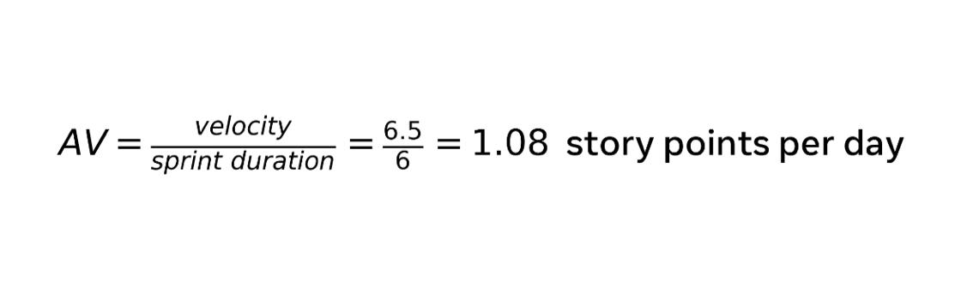

Burndown Chart:
A burn down chart is a graphical representation of work left to do versus time. It is often used in agile software development methodologies such as Scrum. However, burn down charts can be applied to any project containing measurable progress over time.

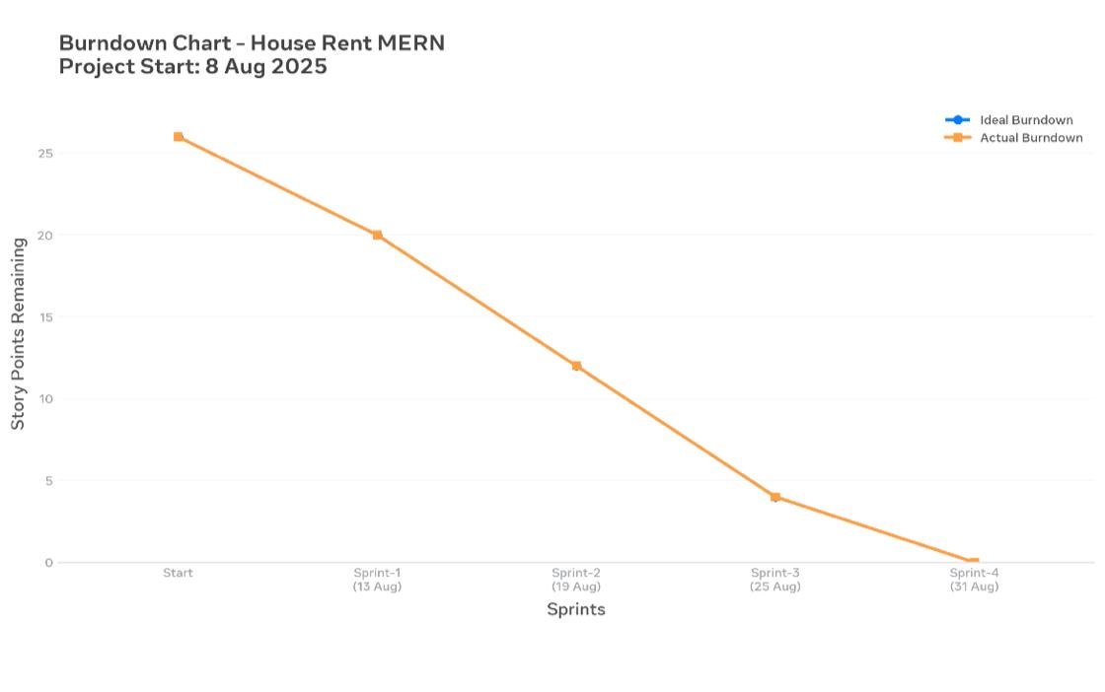

Reference:
https://www.atlassian.com/agile/project-management
https://www.atlassian.com/agile/tutorials/how-to-do-scrum-with-jira-software
https://www.atlassian.com/agile/tutorials/epics
https://www.atlassian.com/agile/tutorials/sprints
https://www.atlassian.com/agile/project-management/estimation
https://www.atlassian.com/agile/tutorials/burndown-charts

